***Product Launch Analysis for Adventure Works***

**Teams Involved:** Sales, Marketing and Product Development

**Key Stakeholder Identification Questions**

1. Briefly explain why any two of the stakeholder groups at Adventure Works may have an interest in the insights related to the sales performance of various products.

Answer:

**Sales Team:** It is undoubtable that the sales team will have the most interest in the insights relating to the performance of products as they will have the key performance indicators regarding sales of various products and hence would be most interested in the knowledge developed from insights of analysis of New Product Launch and its Performance.

**Product Development Team:** This Team is primarily responsible for development and launching of various products in our Adventure Works Organization, hence they can collaborate together with the Sales Department to form our key Stakeholders for this analysis as they both will find the insights quite useful.

1. Which of the stakeholders need to know about customer preferences when it comes to Adventure Works’ products? Why is this information important for them? (Note: Customer preferences refer to customer wants, needs, and expectations regarding products and/or services.)

Answer:

**Product Development Team:** Since the product development team deals mostly with development of the products at our Adventure Works, this team would consider customer preferences at their top priority for the purpose of developing products that suite the larger customer needs, wants and their expectations regarding the products specifically.

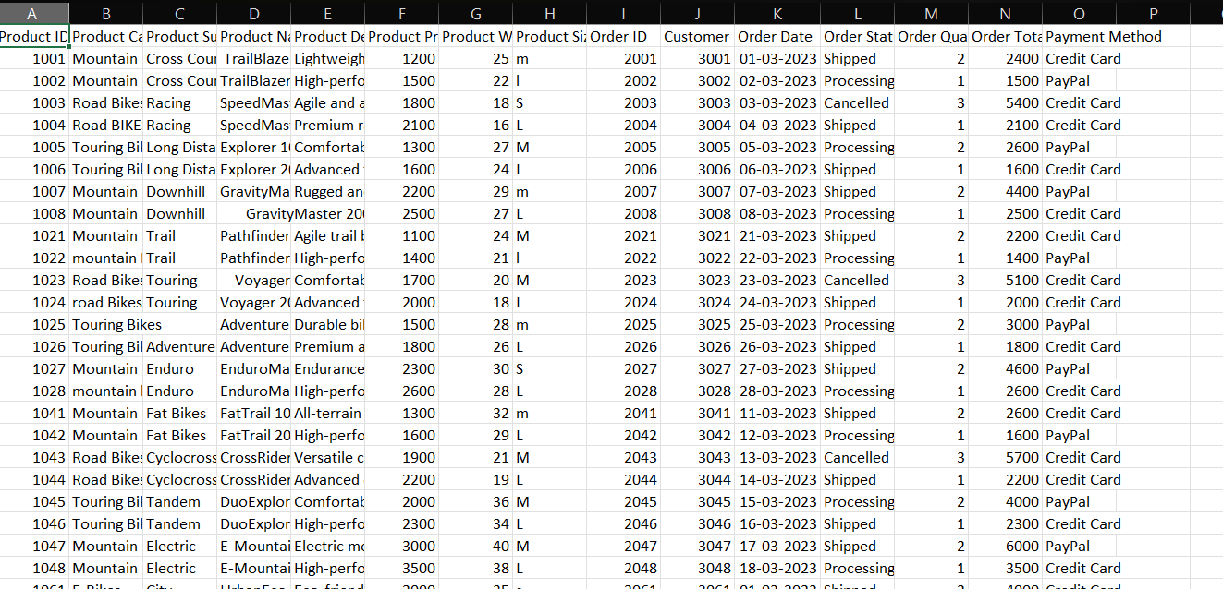

**Answer the following questions to guide your understanding of data sources in the case study:**

1. What kind of information can you gather from the provided dataset in relation to product, order, and customer details?

Answer:

Basic Information like the **maximum ordered product specification, mostly used payment method for order proceedings, Status of orders (Shipped/Cancelled etc.)** and many more basic information regarding the product, orders and customer details can be interpreted from the given dataset as information.

1. How can you use the data fields provided to understand sales trends and customer preferences? Briefly discuss your suggested approach for gaining insight into these two aspects separately.

Answer:

**The Product (Category, Subcategory, Name etc.) can be combined with Order Quantity and Order Total to get**

Which Product actually gives most revenue? **Sales Trend**

Which Product is ordered by Customers in most quantity? **Customer Preference**

Add **Payment Method+ Order Status**

What is status generally of the let’s say Most Revenue Providing Order: **Sales Trend**

What is the mostly used payment method by customers? **Customer Preference**

Is the mostly utilized payment method actually beneficial to Adventure works in terms of sales? **Sales Trend**

**These are just a few examples, with a dataset like this, many other insights can be derived regarding both Sales Trend as well as Customer Preferences.**

1. Explain how the other data sources within Adventure Works might be relevant to your analysis or add value to your insights.

Answer:

**“Additional relevant data sources may include customer details, marketing data, supply chain data, feedback data, and website analytics.”**

Taking this line into consideration:

**Customer details**: Providing a Background of the Customers that can provide you most revenue (for e.g. ethnicity, gender, region etc.)

**Marketing Data**: Which Marketing Strategies (be it digital or offline marketing) proved to be the most beneficial for Adventure Works and specifically for which product?

**Supply Chain Data**: Availability and cost of most successfully performing product of the company, is it actually worth it to invest more in that product and if not, how can investment be redistributed in the Supply Chain of the company so that maximum products can be proven beneficial for the company.

**Feedback Data**: Is the mostly selling product actually benefiting the customers? Customer reviews regarding each of the products of Adventure works which can benefit in understanding the Customer needs and wants.

**Website Analytics**: Is supporting website even beneficial or not for the company by looking at clicks-to-orders ratio?

These are some insights that can be derived from these Additional Data sources apart from just Sales Trends.

**Data Cleaning Related Questions**

1. Name and briefly describe an Excel function that can help you clean the Product Name, Product Category, and Product Size columns.

Answer:

Product Category**: PROPER() – Bringing all the names of product in a Proper case**

Product Name: **TRIM() – Removing additional spaces from Product Names.**

Product Size: **UPPER() – Making Size of Products S/M/L etc. converting them all into proper case**.

1. For the Adventure Works sales dataset, indicate the most appropriate Excel data type for the content of each column. For example, Product ID: Number.

Answer:

ProductID: **Number**

Product Category: **General**

Product Subcategory: **General**

Product Name: **General**

Product Description: **General**

Product Price: **Currency**

Product Weight: **Number**

Product Size: **General**

OrderID: **Number**

CustomerID: **Number**

Order Date: **Date**

Order Status: **General**

Order Quantity: **Number**

Order Total: **Currency**

Payment Method: **General**

1. Explain how you could exclude the missing entry in the Product Description column in the Adventure Works sales dataset at the source using Excel.

Answer:

1. Filter the Product description Column by going to Data Tab🡪 Sort and Filter Group🡪 Filter
2. Next to Column click the Funnel Icon and De-select **Blanks** option